Section 1: Case Summary

Scenario Title: | Pulmonary Embolism
Keywords: | PE, pulmonary embolism, dyspnea, ward medicine
Brief Description of Case: | This case involves the approach to the patient with acute dyspnea. The patient is tachypneic but with an otherwise normal respiratory exam. ECG shows new right heart strain. The resident should consider other possible causes (ACS, CHF, etc) but recognize PE as the most likely cause.  The team is expected to appropriately call for help while initiating management. The patient will decompensate and arrest – thrombolytics should be discussed. The patient will achieve ROSC. The team will provide handover to the code blue team.

Goals and Objectives
Educational Goal: | To enhance resuscitation and team management skills using a pulmonary embolism case requiring rapid critical management and efficient team work.
Objectives:  (Medical and CRM) | - Perform a focused history/physical exam in an acutely unwell patient  - Effectively lead/manage a team to provide appropriate care for an acutely unwell patient  - Recognize risk for PE and initiate the appropriate workup  - Consider the administration of thrombolytics during cardiac caused by PE  - Demonstrate clear leadership and effective team communication  - Appropriately ask for help and communicate concerns over the phone and urgently mobilizes appropriate consultant services.
EPAs Assessed:

Learners, Setting and Personnel
Target Learners:  Location: | ☒ Junior Learners |  | ☐ Senior Learners |  |  | ☐ Staff
 | ☐ Physicians | ☐ Nurses |  |  | ☐ RTs |  |  | ☐ Inter-professional
 | ☐ Other Learners:
Location: | ☒ Sim Lab |  |  | ☐ In Situ |  |  | ☐ Other:
Recommended Number of Facilitators | Instructors: 1
 | Confederates: 1 (RN)
 | Sim Techs: 1

Scenario Development
Date of Development: | 2014
Scenario Developer(s): | Dr Tim Chaplin
Affiliations/Institutions(s): | Queen’s University
Contact E-mail: | chaplintim2@gmail.com
Last Revision Date: | Oct 2019
Revised By: | Dr. Tamara McColl (tamaramccoll@gmail.com)
Version Number: | 2.1

Section 2A: Initial Patient Information

- Patient Chart
Patient Name: Joanna Black |  |  | Age: 69 |  |  | Gender: Female |  | Weight: 70kg
Chief complaint: Shortness of Breath
Temp: 37.2 | HR: 130 | BP: 95/50 |  |  | RR: 28 |  | O₂Sat: 91% |  | FiO₂: Room air
Cap glucose: 8.7 |  |  |  |  | GCS: 15
Triage Note
It’s 1AM and you’ve been called to assess a 69F admitted to the Gyne Oncology unit. She was recently diagnosed with ovarian cancer and is actively receiving chemotherapy. Her repeat CT showed decreased tumor burden and plan is for surgery tomorrow. She was admitted pre-op to receive a blood transfusion for a Hb of 72. The transfusion ended 4 hrs ago and was tolerated well. Approximately 30min ago, the patient started developing shortness of breath and central chest discomfort.

Allergies: None
Past Medical History:  New diagnosis of ovarian ca  Hypothyroidism  GERD  DVT – 1yr ago  Remote Breast ca - 1995 |  |  |  | Current Medications:  At Home: Levothyroxine, Esomeprazole, Zofran, Tylenol#3  Chemo Regimen: Cisplatin, Taxol (last dose 2wks ago)  Added in hospital: Hydromorphone, Tylenol, Gravol

Section 2B: Extra Patient Information

A. Further History
She complains of feeling short of breath and endorses pleuritic chest pain. This started 30 minutes ago. She has never had this feeling before.

B. Physical Exam
List any pertinent positive and negative findings
Cardio: Normal heart sounds | Neuro: nil
Resp: She is visibly dyspneic and struggling to speak. Otherwise, normal respiratory exam. | Head & Neck: nil
Abdo: nil | MSK/skin: nil
Other: The patient appears unwell.

Section 3: Technical Requirements/Room Vision

A. Patient
☒ Mannequin – Adult
☐ Standardized Patient
☐ Task Trainer
☐ Hybrid
B. Special Equipment Required
Code blue cart
Airway cart

C. Required Medications
ACLS medications
TPA

D. Moulage
Hospital gown
20g peripheral IV in place

E. Monitors at Case Onset
Patient on monitor with vitals displayed
Patient not yet on monitor
F. Patient Reactions and Exam
Patient is short of breath and anxious
Will endorse that she is feeling short of breath and will describe a pleuritic centralized chest pain
Will deny any prior history of similar symptoms.

Section 4: Confederates and Standardized Patients

Confederate and Standardized Patient Roles and Scripts
Role | Description of role, expected behavior, and key moments to intervene/prompt learners. Include any script required (including conveying patient information if patient is unable)
Ward Nurse | The ward nurse present in the room should have a headset to allow communication with the control room. They will be the nurse that called the resident to assess the patient and will be familiar with their past medical history and medications Nurse will be helpful and non-obstructive.  Transfusion ended 5hrs ago. Patient was doing very well. Was completely asymptomatic. Now 30 min of severe SOB and pleuritic chest pain. Will ensure the team knows the patient looks unwell. Will point out the O2 saturation, respiratory rate and blood pressure abnormalities.

Section 5: Scenario Progression

Scenario States, Modifiers and Triggers
Patient State/Vitals | Patient Status | Learner Actions, Modifiers & Triggers to Move to Next State |  | Facilitator Notes
1. Baseline State  Rhythm: Sinus Tach  HR: 130  BP: 95/50  RR: 24  O₂SAT: 91% RA  T: 37.2ºC  GCS: 15 | - Appears unwell  - Visibly short of breath  - Pleuritic chest pain | Expected Learner Actions  Focused history/physical  Repeat vitals  Second IV/ Starts IV fluids  Supplemental O2  ECG/CXR/Bloodwork  Calls for help  Clarifies goals of care | Modifiers  - O2 sats will drop if no supplemental O2 applied  - BP will improve with IVF  Triggers  - Can move on to next state when initial assessment complete
2. Decompensation  Rhythm: Sinus Tach  HR: 135  BP: 88/50  RR: 26  O₂SAT: 90% (on O₂)  GCS: 15 | - Patient becoming more SOB  - 1-2 word dyspnea. | Expected Learner Actions  Interprets ECG and CXR  Correctly diagnosis PE  Considers imaging vs TPA  Calls a code blue as patient is deteriorating | Modifiers  - If no discussion of PE, RN to provide a hint  Triggers  - Diagnosis made and additional help is called | * Can provide ECG  * Can provide VBG  * Can provide CXR
3. PEA Arrest  Rhythm: Bradycardia  HR: 30  BP: --/--  RR: --  O₂SAT: --  GCS: 3 | - Patient will arrest | Expected Learner Actions  High quality CPR  Epinephrine 1mg iv q3min  IVF  Intubation  Voicing Hs and Ts  Calls for TPA | Triggers  - ROSC after 3 cycles (with or without TPA administration)
4. ROSC + Handover  Rhythm: Sinus Tach  HR: 110  BP: 92/50  RR: 16  O₂SAT: 94% (Vent)  GCS: 3 | - Patient non-responsive | Expected Learner Actions  Post-intubation care repeat vitals, CXR, sedation.  Provide a comprehensive patient handover in SBAR format | Triggers  - Case ends after handover | *The ICU fellow/staff will arrive at this stage post intubation

Appendix A: Laboratory Results

Only VBG will be available:

VBG
pH 7.27
pCO₂ 31
pO₂ 47
HCO₃ 18
Lactate 2.9
Na 131
K 3.7
Glc 5.1

Appendix B: ECGs, X-rays, Ultrasounds and Pictures

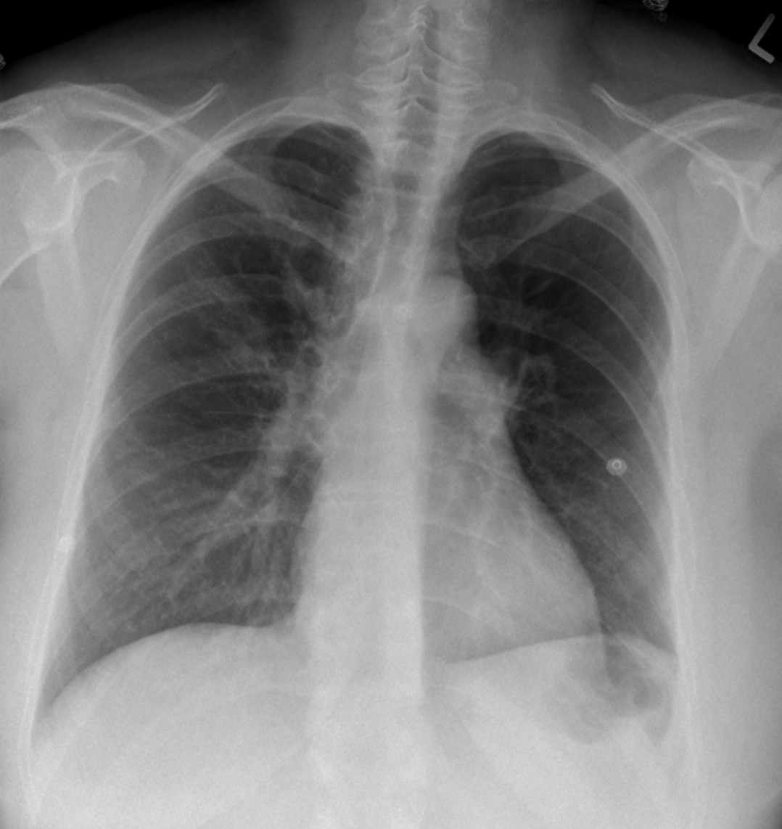
Source: https://openpress.usask.ca/undergradimaging/chapter/pulmonary-thromboembolism/

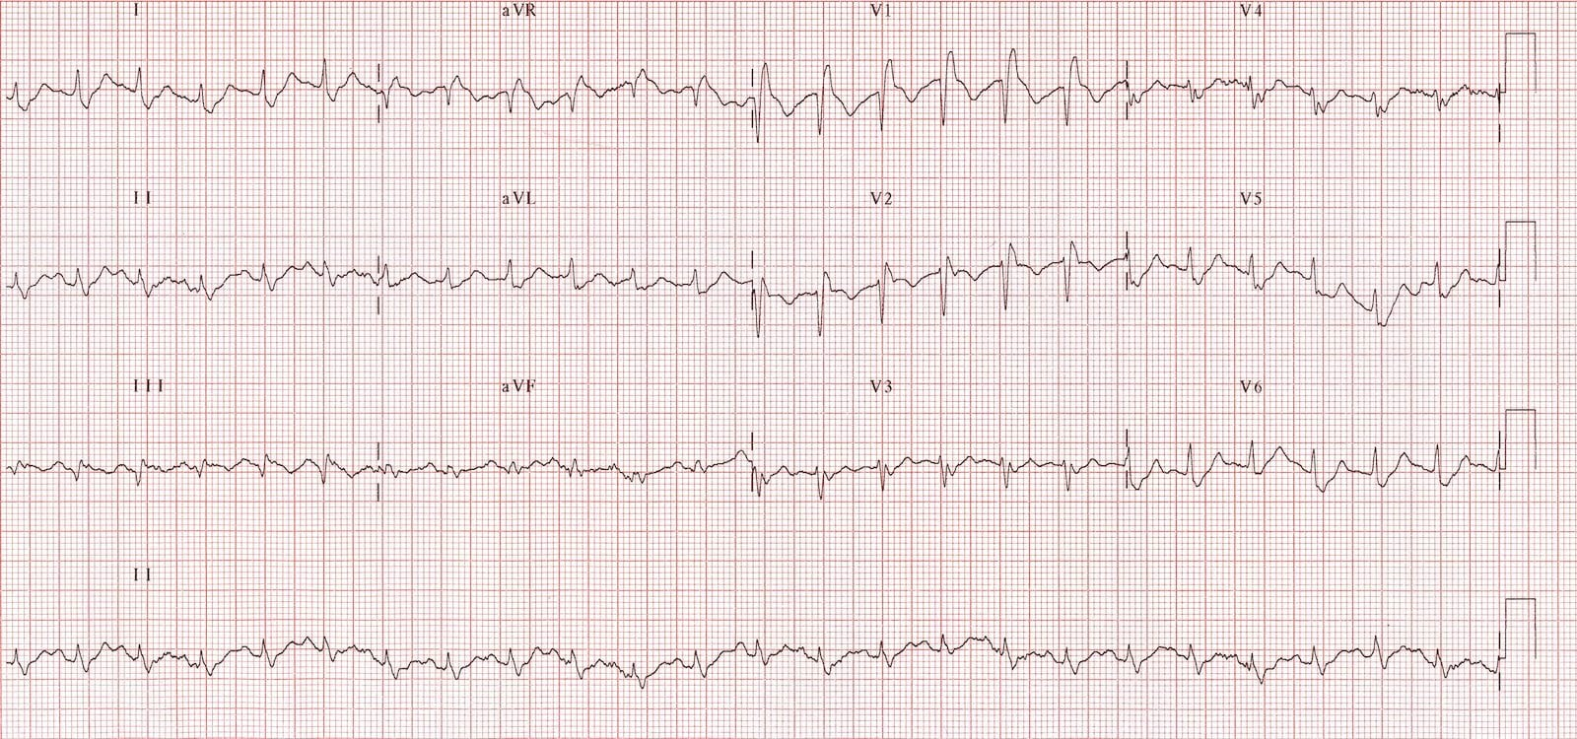
Source: https://litfl.com/ecg-changes-in-pulmonary-embolism/

Appendix C: Facilitator Cheat Sheet & Debriefing Tips

Include key errors to watch for and common challenges with the case. List issues expected to be part of the debriefing discussion. Supplemental information regarding any relevant pathophysiology, guidelines, or management information that may be reviewed during debriefing should be provided for facilitators to have as a reference.

Common Challenges:
- Working through the differential diagnosis of acute respiratory failure
- Providing critical care on the ward
- “Pulling the trigger” on thrombolytics

Debrief Discussion:
- Differential diagnosis of respiratory failure
- Identification of patients that will benefit from thrombolytics
- Therapeutic options for the arrested patient
- Clear communication of the patient’s clinical state and treatment plan with senior staff

References

1. Josh Farkus. 2019. Submassive and Massive PE. Internet Book of Critical Care. https://emcrit.org/ibcc/pe/

2. Amit Shah. 2018. PE Thrombolysis. Emergency Medicine Cases. https://emergencymedicinecases.com/video/emu-365-pe-thrombolysis-in-2018/

3. Peter Reardon et al. 2018. Contemporary Management of the High-Risk Pulmonary Embolism: The Clot Thickens. Journal of Intensive Care Medicine. 34(8):603-608

